www.quasiturbine.com/QTPapiers/QUASITURBINEVishnuSKumar201103.doc

A REPORT ON
QUASITURBINE ENGINE
“A PROVEN PROMISE FOR THE FUTURE”
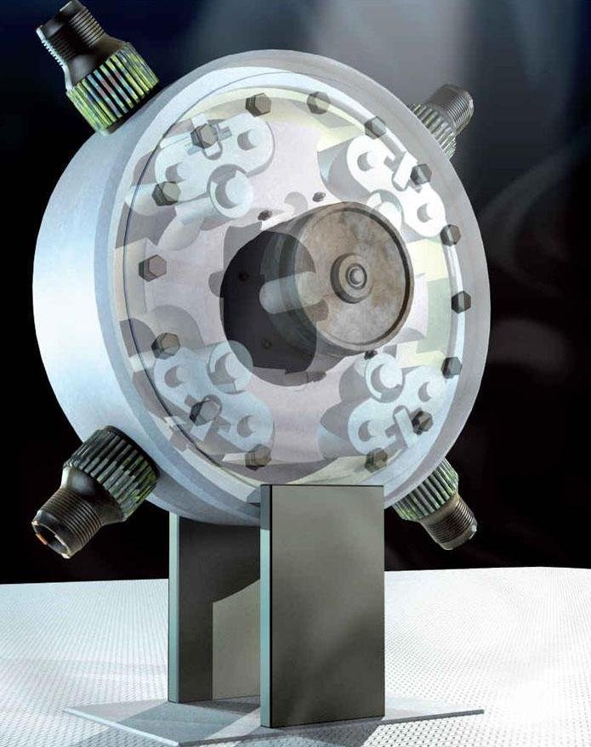
By
VISHNU S KUMAR
NSS COLLEGE OF ENGINEERING
PALAKKAD – KERALA - INDIA
MARCH 2011
- QUASITURBINE OVERVIEW
The Quasiturbine www.quasiturbine.com concept resulted from the research that began with an intense evaluation of all engine concepts to note their advantages, disadvantages and to check the opportunities for improvement. The Quasiturbine Engine was invented by the Saint-Hilaire team headed by Dr. Gilles Saint-Hilaire and was first patented in the year 1996. The team on their exploratory process realized that a unique engine solution would be one that perfects the piston engines and improves the Wankel engine.
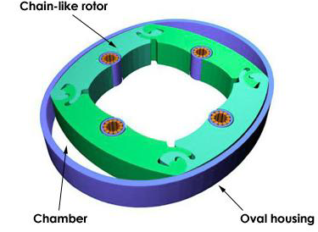
The Quasiturbine or Qurbine is a pressure driven continuous torque deformable spinning wheel. It can be considered to be the crossroad of three modern engines – Inspired by the turbine, it perfects the piston and improves upon the Wankel.
A Qurbine (in short) is thus a non-crankshaft rotary engine having a four faced articulated rotor with free and accessible center, rotating without vibration and producing high torque at low RPM. The rotor as an assembly is deformable and the four faces are joined together by hinges at the vertices. The volume enclosed between the blades of the rotor and stator casing provides compression and expansion in a fashion similar to the Wankel engine. The hinging at the edges allows higher compression ratio and different time dependencies, while suppressing the Wankel rotor dead time and that too without any complex rotor synchronization gears. The Quasiturbine can be considered to be an optimization theory for extremely compact and efficient engine concepts.
- CONFIGURATIONS OF A QURBINE
Quasiturbine engines can be designed in two different configurations:
- Simple Configuration – without carriages
- Advanced configuration – with carriages
2.1 QURBINE WITHOUT CARRIAGES
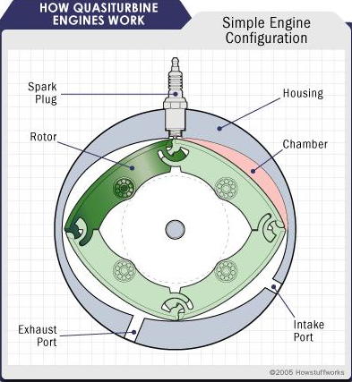
QT engine without carriages or in Simple configuration is very much similar to a conventional rotary engine. It has a rotor that revolves with in the housing. The engine makes use of complex computer calculated oval shape stator housing, creating regions of increasing and decreasing volumes as the rotor runs. The rotor has four blades hinged to each other at their ends. The sides of the rotor seal against the sides of the housing, and the corners of the rotor seals against the inner periphery, dividing it into four chambers. The four strokes of an engine are sequentially arranged the housing.

2.2 QURBINE WITH CARRIAGES
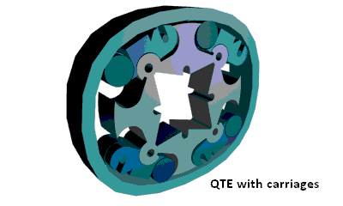
QT with carriages is specially designed for a superior mode of combustion called as Photo Detonation which requires higher compression and sturdiness. In this configuration, the rotor is composed of four pivoting blades which do a similar function as the piston. At one end of the pivoting blade, it has a hook pivot and on the other end a cylinder pivot. Each pivot sits intone of the four rocking carriages. Each carriage is free to rotate around the same pivot in such a way as to be continuously and precisely in contact with the housing. The filler tip on the blade is meant to control the residual volume in the chamber. The top of the filler tip is shortened to permit an adequate compression ratio. The traction slot on the other side of the blade is meant to couple it with an external shaft so as to draw the power generated. The wheels on carriages are made larger so that it reduces the contact pressure on the housing and also ensures a smooth motion of the rotor.
The housing (stator) has a computer generated unique profile which is almost near to an oval shape and it is called “Saint-Hilaire Skating Rink”. The housing has four ports on it :
- An intake port – to intake of air
- A port where the spark plug is placed
- A port that is closed by a removable plug
- An exhaust port – to expel the combusted gases
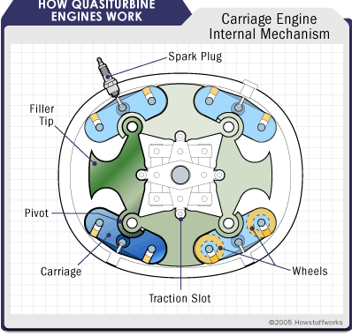
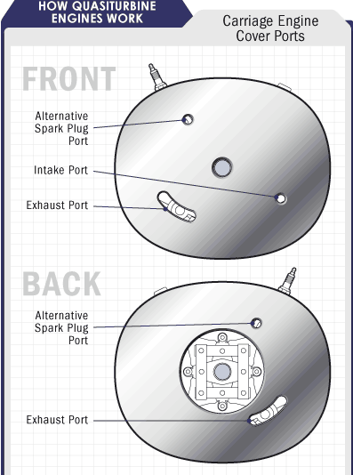
The housing is enclosed on each side by two covers, which also have three ports of their own, allowing for maximum flexibility in how the engine is configured. For example, one port can serve as an intake from a conventional
carburetor or fitted with a gas or diesel injector, while another can serve as an alternate location for spark plug. One of the three ports is made large to expel the exhaust gas.

- WORKING
The working of a Quasiturbine engine is very similar to that of a conventional rotary engine. The four strokes are sequentially arranged around the housing.
As the rotor turns, its motion and the shape of the housing cause each side of the housing to get closer and farther from the rotor, compressing and expanding the chambers similar to the strokes in a reciprocating engine. The Qurbine is capable of producing eight combustion strokes per two revolutions in place of one combustion stroke per revolution in a piston engine.
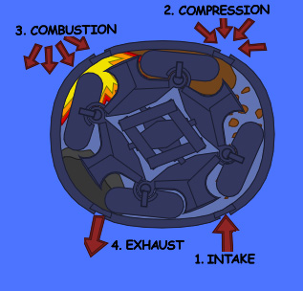
Suction: The charge (air or fuel-air mixture) enters into the engine through the inlet port. The inlet port is designed such that the entering air would push the rotor forward and starts its rotation. As the charge enters in to the chamber, its volume increases i.e. it undergoes expansion within the chamber.
Compression: The rotational movement of the charge causes the expanded gas to undergo compression in the next chamber. The volume of the second chamber is so small that the charge is tremendously compressed and high compression ratio is achieved. As the charge is compressed, its temperature is also raised to a much higher value.
Combustion: Towards the end of the compression stroke, the compressed charge is ignited. The ignition causes the whole charge to undergo combustion at a fast rate and it releases a large amount of energy. This energy is utilized by the rotor for further rotation. Thus the rotor does not require an external drive shaft to cause the rotation.
Exhaust: The combustion of gas takes place with immediate increase in the volume i.e. the charge undergoes expansion as soon as the combustion takes place and then it is expelled out of the engine through the exhaust port. The highlight of the QT engine is that it enables continuous combustion. One combustion stroke is ending right when the next stroke is ready to fire. A small channel along the internal housing wall next to the spark plug takes a small quantity of hot gas back to the charge that is ready to fire, which in turn assists the combustion.
Thus the four chambers produce two consecutive circuits. The first circuit is used to compress the charge and expand the gas during combustion. The second is used to expel the exhaust and to intake fresh charge.

- COMBUSTION MODE
The combustion mode in an internal combustion engine fall into following categories based on how well air and fuel are mixed together in the combustion chamber and how the fuel is ignited.
Type I regards with gasoline engines in which the air and the fuel mix thoroughly to form a homogenous mixture. When a spark ignites the fuel, a hot flame sweeps through the mixture, burning the fuel it goes through.
Type II deals with gasoline direct injection engine which uses partially mixed fuel and air i.e. a heterogeneous mixture, which is directly injected into the cylinder rather than into an intake port. A spark plug then ignites the mixture, burning more of the fuel creating less waste.
In TYPE III, air and fuel are only partially mixed in the combustion chamber. This heterogeneous mixture is then compressed, which causes the temperature to rise until self-ignition takes place.
In Type III i.e. in a diesel engine air and fuel are only partially mixed in the combustion chamber. This heterogeneous mixture is then compressed, which causes the temperature to rise until self-ignition takes place. A diesel engine operates in this fashion.
Type IV has the best attributes of the gasoline and diesel engine combined in it. A premixed fuel air charge undergoes tremendous compression until the fuel self ignites. It employs a homogeneous charge and compression ignition and is termed as Homogeneous Charge Compression Ignition. Due to its shortened pressure pulse, the QT compression temperature increases rapidly at the pressure to exceed all the ignition and combustion parameters in a very short time. The combustion is then driven by the intense radiation in the chamber. Thus, it results in complete combustion of the fuel, leaving behind no hydrocarbons to be simply expelled into the air and so it ensures virtually no toxic emissions and superior fuel efficiency.

- QUASITURBINE vs. OTHER ENGINES
5.1 TURBINE COMPARISON
The word Quasiturbine literally means ‘similar to turbine’ and is so called because, like turbines QT is also capable of producing flatter torque. The primary energy output of the combustion of the fuel is the Pressure energy. QT, being a hydro-aerostatic device, directly transforms this pressure energy into mechanical motion. Conventional turbines are hydro-aerodynamic device which converts the pressure energy of the fluid into mechanical energy through an intermediate kinetic energy and hence its efficiency changes with variation in the flow velocity.
5.2 PISTON COMPARISON
The piston engines being the most common engine reference, the QT research team has initially established a list of conceptual piston open for improvement. The QT concept is the result of an effort to improve the piston engine and indirectly other engines including Wankel.
5.2.1 PISTON DEFFICIENCIES
- All the processes are taking place in one single chamber. Hot process will destroy the efficiency of cold process and vice versa
- The piston makes positive torque only 17% of time and drag 83% of time
- The gas flow is not unidirectional, but changes direction with the piston direction
- The valves open only 20 % of the time, interrupting the flows at intake and at exhaust 80% of the time
- The duration of the piston rest time at top and bottom are without necessity too long
- Long top dead center confinement time increase the heat transfer to the engine block reducing engine efficiency
- The non-ability of the piston to produce mechanical energy immediately after the top dead center
- The proximity of the intake valve and the exhaust valve prevents a good mixture filling of the chamber and the open overlap lets go some un-burnt mixture into the exhaust
- The piston does not stand fuel pre-vaporization, but requires fuel pulverization detrimental to combustion quality and environment
- The average torque is only 15% of the peak torque, which imposes construction robustness for the peak 7 times the average
- The flywheel is a serious handicap to accelerations and to the total engine weight
- The valves inertia being a serious limitation to the engine revolution
- The heavy piston engines require some residual compressed gas before top dead center to cushion the piston return
- The internal engine accessories (like the cam shaft) use a substantial power.
- Complete reversal of the flows from intake to exhaust
- At low load factor, the intake depressurization of the Otto cycle dissipates power from the engine (vacuum pump against the atmospheric pressure)
5.2.2 QT and Piston Side by Side
Like the piston engine, the QT is a volume modulator of high intensity and acts as a positive displacement engine.
Better torque continuity and acceleration: The crankshaft and the flywheel are the main obstacle to engine acceleration, and since the flywheel are unable to store energy at low rpm, the engine torque at idle is highly handicapped by the engine dead times. The piston of a 4-stroke engine works in power mode about 120 degrees / 720 degrees (2 turns), and thus constitutes a drag 80% of time, period during which the flywheel assumes a relative torque continuity. The Quasiturbine has jointed torque impulses, and presents a profile of almost flat torque characteristics, without the assistance of a flywheel.
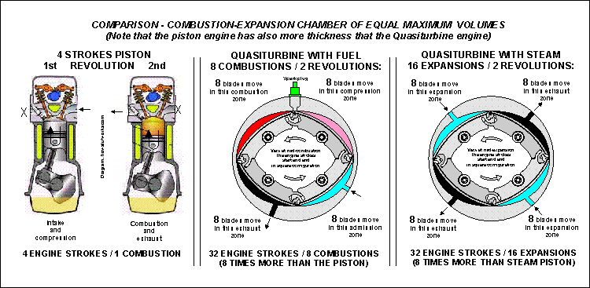
Low revolution – Reduction of gearbox ratio: The gear boxes are evils necessary (expensive, complicated, delicate, and energy consuming). The RPM required by the human activity are generally lower that the performance optimum speed of the engines (e.g.: an automobile wheel generally does not rotate to more than 800 or 1000 RPM, which is 4 to 5 times less than the engine RPM). As the Quasiturbine turns 4 to 5 times less quickly than the other engines, the gear boxes can often be removed (amongst other things in the field of transport) with an increase in efficiency.
Continuous combustion with lower temperature: As the Quasiturbine strokes are jointed (what is not the case with the Wankel), the lighting is necessary only in launching, since the flame transfers itself from one chamber to the following. The thermalisation of the Quasiturbine by contacts with rollers is more effective, and prevents hot point. From the thermal point of view, the Quasiturbine does not contain any internal parts requiring coolant fluid (like oil).
Better overlaps: The intake and exhaust ports being at different ends of the combustion chamber, it is possible to do a better filling of the chamber by having a simultaneous open overlapping of the two ports, without risking that a portion of the intake gas goes into the exhaust, as it is the case with the piston engine.
5.3 WANKEL COMPARISON
Today's Wankel engines technology is well mastered, but the concept does still present major drawbacks. Because hundreds of experts could not pin point the exact reason for the poor Wankel combustion, they have "vaguely attributed it without proof" to the elongated shape (high surface to volume ratio) of the Wankel combustion chamber.
5.3.1 QT and Wankel Side by Side
The Wankel engine uses a rigid three faces rotor with a crankshaft.
The Quasiturbine uses a deformable four face rotor without a crankshaft.
- The Wankel engine shaft turns at three times its rotor RPM. The Quasiturbine rotor and main shaft turns at the same speed.
- The Wankel engine fires only once per shaft (not rotor) revolution (which means three times per rotor revolution). The Quasiturbine fires four times per main shaft revolution, producing strong and exceptional torque continuity.
- The Wankel compression and combustion stroke each last 120 degree of rotor (not shaft) rotation, of which only 90 degrees is effective (no chamber volume variation in the first 30 degrees of compression and in the last 30 degrees of combustion). Exhaust and intake strokes share together 120 degree of rotation in an excessive overlapping. In term of time management, the Wankel is even worst than the piston. All Quasiturbine strokes are of equal 90 degrees rotor rotation (not necessarily duration), with useful volume variation (like piston) at all angles and without undesired overlapping.
- In the Wankel, 2/3 of the work is produced by piston like radial crankshaft force, while 1/3 of the work is done by pure rotational (tangential) force, which the crankshaft is not optimized to harvest (and for which a synchronization casing gear is needed). In the Quasiturbine, 100% of the work comes from tangential forces and movement, which the tangential differential harvests correctly.
- The Wankel excessive engine ports overlap imposes to trunk the power stroke somewhat before the bottom dead center BDC, which results in some lost of efficiency. In the Quasiturbine, the power stroke extends until it is fully completed.
- When the Wankel engine rotor goes from one TDC (top dead center) to the next, the torque increases to a maximum value and starts decreasing right away. The torque generated by the Quasiturbine (accentuated on AC type) gets toward a plateau, and holds this maximum for a longer arc before decreasing, producing a better overall mechanical energy conversion rate.
- The center of mass of the Wankel triangular piston is moving in circle with the crank, and this whole triangular mass tends to bang the seals against the housing, requiring the protection of a housing synchronization gear. The Quasiturbine has no crankshaft, and its rotor center of mass is immobile at the center during rotation. Never the Quasiturbine seals need to oppose and constraint the whole rotor mass, the only force required being the one to transform a square into lozenge and back to square.
- The Wankel engine cannot operate in continuous combustion. While a full expansion stroke occurs (rotor revolution of 90 degrees), intake mixture compression is only partially initiated and not yet ready to be lighted (an additional 30 degrees rotor rotation is required as a dead time). Quasiturbine mixture is completely compressed and ready to fire at the end of each expansion stroke, making possible a flame transfer for continuous combustion.
- Due to its one single firing per shaft revolution, and the dead time, the Wankel engine needs a flywheel. The Quasiturbine needs no flywheel, and consequently has faster acceleration.
- The Wankel engine is a "rotating piston engine" that is subject to a constant circular vibration. The Quasiturbine has a fixed center of gravity during rotation, and is a true zero vibration engines (like the turbine), since any weight movement is exactly compensated by symmetric mirror movement through the center. (Be careful not to confuse vibration with unidirectional counter-torque impulses).
- Since the main Wankel engine shaft rotates at three times its rotor speed, it is more suitable for high RPM end uses. The Quasiturbine main shaft (rotating at the same speed as its rotor) is more appropriate for lower revolution uses (e.g. airplane propeller at only 2000 RPM, generator, transportation, or to reduce gearbox ratio in current applications).

- QUASITURBINE PECULIARITIES
- Rapid transition at dead points: The "Saint-Hilaire skating rink profile" allows the fastest possible transition around the top dead center (TDC). Considering that the successive seals move in the inverse direction, all improvement to the rate of radial variation is doubled in effect. In this case, a rotor move of no more than 10 degrees brings the engine at 50% of its maximum torque.
- Torque continuity: Contrary to most rotating devices which are progressive, meaning that the torque is nil at TDC and increases progressively until a maximum is reached, the Quasiturbine "Saint-Hillaire skating rink profile" rapidly reaches the maximum diameter, and then follows it with accuracy on its entire length. The continuous combustion permits optimization of torque continuity. In assembling 2 units with a phase difference of 45 degrees, one assures a positive torque for any angle of the engine shaft, even at zero rpm.
- High compression ratio: At the design parameter selection level, rotating engines generally present a dilemma. If one wants to increase the compression ratio, the intake volume has to decrease to an unacceptable level, thus imposing large engine dimensions. The Quasiturbine does not present this dilemma, and permits construction of a compact detonation or diesel engine. One understands that the compression and exhaust is done on a 77.7 degrees range, while the expansion (intake) occurs on a 102.3 degrees range. This asymmetry brings the seals closer together to give a higher compression ratio and allows the maximum extraction of energy by an extended expansion cycle.
- Leak proof: The Quasiturbine does not have the critical leak proof problem of the Wankel. Since the Quasiturbine seals are seated on rocking carriers, they are perfectly perpendicular to the engine profile at all time. Furthermore, it should be noted that if the carrier wheels are tight fit into the carrier, the wheels themselves are contributing to seal the two consecutive chambers.
- Zero vibration on the shaft: The Quasiturbine is a true rotating engine with a stationary gravity center during rotation devoid of any vibration on the shaft .On the other hand, the Wankel is a "rotary piston" engine that is subject to a constant circular vibration.
- Fast acceleration: Due to the absence (and no need) of the flywheel and due to its low intrinsic inertia, the Quasiturbine is capable of fast accelerations, including at low rpm. This quality makes it a "nervous" engine and susceptible to please amateurs of sport engine devices.
- Construction and reliability: The rotating engines are generally comprised between a robust external profile and a central shaft seated on strong bearings which are able to take the load on the shaft created by combustion pressure. For its part, the Quasiturbine requires only a robust external profile on which the combustion pressure load also applies; the central shaft is elective and only dedicated to torque transfer when required. Furthermore, contrary to the Wankel, the Quasiturbine does not need any synchronization gears or any spark plug synchronization. Conventional engines have achieved excellent reliability considering their pumps, camshaft, rockers, push rod, springs, electrical distribution etc. Having none of these devices, the Quasiturbine is then easier to build, and eventually considerably more reliable. Having a low RPM, the Quasiturbine has a better resistance to wear out and last longer.
- Energy savings: The Quasiturbine allows important energy savings without having pretensions of a better thermodynamic performance than any other engine. The best power to weight ratio of the Quasiturbine (to which the flywheel suppression contributes) gives rise to lighter vehicles (also due to the suppression of the gearbox) and fuel cost efficiency. The fact that the Quasiturbine does not require energy consuming peripherals (pumps, camshafts, push rods, valves etc.) also constitutes a gain at the level of energy efficiency.
- Environmental Considerations: In the Quasiturbine engine, intake mixtures never come into contact and neither are "pushing" the exhaust gases. Consequently, the Quasiturbine has power characteristics of the 2 cycle engine, while meeting the excellent exhaust combustion of the 4 cycle engine.
- Variety of fuels: In engine mode, the Quasiturbine is an excellent pressured fluid energy converter. Large units may be used to produce electricity in coal or heavy oil thermal power plants, or to transform in mechanical energy the residual steams of industrial processes. In addition to the use of conventional liquid petroleum fuels, the Quasiturbine can in principle make use of (if adapted) a wide variety of fuels from methanol to diesel oils, including the kerosene, the natural gas and eventually the hydrogen.
- High power density: In order to achieve high power density (in volume and weight), the concept and design of engine must make sure that all components are continuously essential at all time. For example, the pistons of a car engine being independent, each piston is useful while propulsive (17% of the time), but present a rest and an unfortunate drag for most of the time (83%). In the Quasiturbine, all components are continuously essential at all stage of operation, and none experience any dead time.
- QUASITURBINE APPLICATIONS
7.1 The Return of Steam Engine
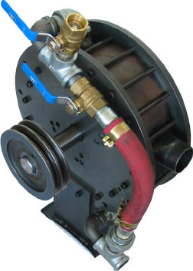
Solar, geothermal, biomass, cogeneration and heat recovery are natural applications for the Quasiturbine steam engine due to its simplicity, low price and low maintenance cost. Steam pressure less than 60 psi (often saturated steam) is generally much less regulated and most suitable for the Quasiturbine. Flashing water (steam keep in liquid state in the supply line to ensure maximum heat transfer) into a hot Quasiturbine is also a very safe technique removing the need of a boiler.

7.2 Engine Exhaust Heat Recovery
Engine Exhaust recovery, using the exhaust heat energy to drive the same engine, reduces the fuel consumption of the engine still maintaining the same overall power level, but at a higher efficiency. Quasiturbine Stirling and Quasiturbine Brayton thermal cycles offer enhanced possibility for efficient moderate temperature heat conversion into mechanical energy. A 30 % engine heat recovery efficiency (not easy to achieve, but feasible) would out-perform most hybrid concepts. A simple way is to heat a steam Quasiturbine engine block by placing it in or around the exhaust pipe (corrosive condensation will not affect the inside) and flashing hot pressurized water steam (steam kept in liquid state in the supply line to ensure maximum heat transfer) directly into the chambers. The Quasiturbine offers a unique flow and power modulation by alternate use of one or both of its double internal quasi independent circuits, which allows power modulation of the Quasiturbine Ranking and Brayton cycles and also other important thermal cycles.

7.3 Other Applications
Quasiturbine can be used particularly for low noise and vibration sensitive applications. Reduction in size and weight for a given power output enables it to be used as a substitute for general engines. It is most appropriate for zero vibration hand tools, chainsaws, go-karts etc. The Quasiturbine is highly suitable as air compressor and water pump, hydraulic pump and motor, turbo-pump etc. as well.

- ADVANTAGES
- The QT efficiency remains high over a wide power range without use of hybrid technology. (Efficiency of a piston engine falls off rapidly below rated engine power.)
- The QT engine provides power nearly 100% of the time. (Each piston of a piston engine can provide power less than 20% of the time and creates a power drag more than 80% of the time.).
- Peak power in a QT engine is only about 20% greater than the average power. (Peak power in a piston engine is about 700 percent greater than the average power. Since the engine structure must be designed to accommodate the peak power rather than the average power, and since the QT the combustion chamber is used 800 percent more of the time than does the piston engine, the weight of a QT engine for the same power could be only about 20 percent that of a piston engine with the same power).
- The QT engine would provide generally higher thermal efficiency and produces less pollution than the piston engine.
- The QT’s simple construction with many less moving parts would provide greater reliability at a lower cost than a piston engine. Also lower friction would further improve the efficiency.
- The QT is a rotary engine, has no crankshaft, and parts do not have to reverse direction like in the piston engine; therefore, the QT engine produces has much less noise and vibration. The engine is balanced; therefore, no counter balances are required.

- CONCLUSION
The Quasiturbine is thus a pressure driven engine producing continuous torque with a symmetrically deformable spinning wheel. It is a new engine alternative with some characteristics simultaneously common to the turbine, Wankel and piston, offering top efficiency power modulation capability. The most important characteristic is the fact that it does support detonation (HCCI), where piston engine has not succeeded over the last decades. The detonation auto-ignites similarly to what happens in Diesel, but burns homogeneously, faster and cleaner.
The basic limitation of the Quasiturbine engine www.quasiturbine.com at a present stage is that it is in its infancy stage. Though a lot of advancement has been made since its invention has been marked, it has been commercialized only in 2 and 12 kW air and steam motor for now. Its performance has been tested by using it in go-kart vehicle, pneumatic compressor etc. Moreover, QT is a new technology probably unwelcome in the world of engine establishment. At present most of the companies have already made large investments for improving the existing engine and hence there has not been much of encouragement for its development. Solar and heat recoveries are much in a need of such a technology, which is progressively adopted…

- REFERENCES
- GILLES SAINT-HILAIRE, ROXAN SAINT-HILAIRE and YLIAN SAINT-HILAIRE, ASME paper on Quasiturbine Low RPM High Torque Pressure Driven Turbine for Top Efficiency Power Modulation, May 2007
- CAROL CROM, A white paper on “Quasiturbine Technical Discussion Comparing the Quasiturbine with other Common Engines”, October 2005
- MYRON D. STOCKS, A white paper on “The Saint-Hilaire Quasiturbine as the Basis for Simultaneous Paradigm Shift in Vehicle Propulsive Systems”, December 2003
- www.quasiturbine.com accessed in February 2011

By: Vishnu S Kumar
Mechanical Engineering
NSS Engineering College, Palakkad,
Kerala – India
vishnu.8919@gmail.com
March 2011

Original document at :
www.quasiturbine.com/QTPapiers/QUASITURBINEVishnuSKumar201103.doc

